

Binary Search Tree Code
The TreeNode & BinarySearchTree Classes

public class TreeNode {
private Object item;
private TreeNode leftChild;
private TreeNode rightChild;

public TreeNode(Object newItem) {
// Initializes tree node with item and no children.
item = newItem;
leftChild = null;
rightChild = null;
} // end constructor

public TreeNode(Object newItem,
TreeNode left, TreeNode right) {
// Initializes tree node with item and
// the left and right children references.
item = newItem;
leftChild = left;
rightChild = right;
} // end constructor

public Object getItem() {
// Returns the item field.
return item;
} // end getItem

public void setItem(Object newItem) {
// Sets the item field to the new value newItem.
item = newItem;
} // end setItem

public TreeNode getLeft() {
// Returns the reference to the left child.
return leftChild;
} // end getLeft

public void setLeft(TreeNode left) {
// Sets the left child reference to left.
leftChild = left;
} // end setLeft

public TreeNode getRight() {
// Returns the reference to the right child.
return rightChild;
} // end getRight

public void setRight(TreeNode right) {
// Sets the right child reference to right.
rightChild = right;
} // end setRight
} // end TreeNodeCode

public class KeyedItem {
private Comparable searchKey;
public KeyedItem(Comparable key) {
searchKey = key;
} // end constructor
public Comparable getKey() {
return searchKey;
} // end getKey
public String toString() {
return "" + searchKey;
}
} // end KeyedItem

public class BinarySearchTree extends BinaryTreeBasis {
// inherits isEmpty(), makeEmpty(), getRootItem(), and
// the use of the constructors from BinaryTreeBasis

public BinarySearchTree() {
}

public BinarySearchTree(KeyedItem rootItem) {
}

public void insert(KeyedItem newItem) {
root = insertItem(root, newItem);
}

public KeyedItem retrieve(Comparable searchKey) {
}

public void delete(Comparable searchKey)throws TreeException {
}

public void delete(KeyedItem item) throws TreeException {
}

protected TreeNode insertItem(TreeNode tNode, KeyedItem newItem) {
TreeNode newSubtree;
if (tNode == null) {
// position of insertion found; insert after leaf; create a new node
tNode = new TreeNode(newItem, null, null);
return tNode;
} // end if
KeyedItem nodeItem = (KeyedItem)tNode.getItem();

// search for the insertion position
if (newItem.getKey().compareTo(nodeItem.getKey()) < 0) {
// search the left subtree
newSubtree = insertItem(tNode.getLeft(), newItem);
tNode.setLeft(newSubtree);
return tNode;
}
else { // search the right subtree
newSubtree = insertItem(tNode.getRight(), newItem);
tNode.setRight(newSubtree);
return tNode;
} // end if
}
}

Sample Client File for Binary Search Tree Lab
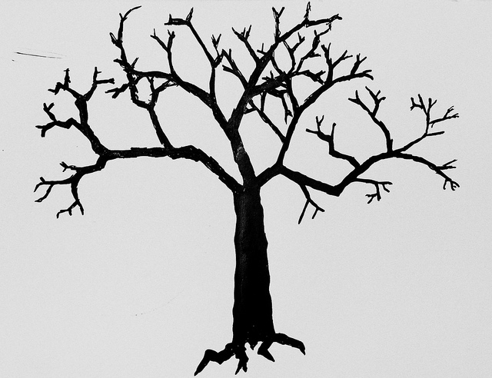

public class MyTree
{
public static void main(String[] args)
{
BinarySearchTree t = new BinarySearchTree();

t.insert(new KeyedItem("M"));
t.insert(new KeyedItem("J"));
t.insert(new KeyedItem("D"));
t.insert(new KeyedItem("F"));
t.insert(new KeyedItem("L"));
t.insert(new KeyedItem("W"));
t.insert(new KeyedItem("S"));
t.insert(new KeyedItem("T"));
t.insert(new KeyedItem("Z"));

t.inorder();
t.preorder();

BinarySearchTree myCopy = new BinarySearchTree();

myCopy.insert(new KeyedItem("M"));
myCopy.insert(new KeyedItem("J"));
myCopy.insert(new KeyedItem("D"));
myCopy.insert(new KeyedItem("F"));
myCopy.insert(new KeyedItem("L"));
myCopy.insert(new KeyedItem("W"));
myCopy.insert(new KeyedItem("S"));
myCopy.insert(new KeyedItem("T"));
myCopy.insert(new KeyedItem("Z"));

if (t.duplicateCheck(myCopy))
System.out.println("They're Duplicates");
else
System.out.println("They're Not Duplicates");

t.delete("M");
t.preorder();
}
}
Using a Binary Search Tree Class to Create a Concordance

The line numbers shown to the left of the text are for your reference only. They are not included in the input file.

1 Jingle bells, jingle bells,
2 jingle all the way!
3 O' what fun it is to ride
4 In a one-horse open sleigh
5
6 Dashing through the snow
7 On a one-horse open sleigh,
8 Over the fields we go,
9 Laughing all the way;
10 Bells on bob-tail ring,
11 making spirits bright,
12 What fun it is to ride and sing
13 A sleighing song tonight
14
15 Jingle bells, jingle bells,
16 jingle all the way!
17 O' what fun it is to ride
18 In a one-horse open sleigh

Sample Text Output File

ooooooooooooooooooooooooooooooooooooooooooooooooo
THE CONCORDANCE
ooooooooooooooooooooooooooooooooooooooooooooooooo

WORD LINES FOUND
-------------------------------------------------
all 2 9 16
and 12
bells 1 10 15
bob 10
bright 11
dashing 6
fields 8
fun 3 12 17
go 8
horse 4 7 18
in 4 18
is 3 12 17
it 3 12 17
jingle 1 2 15 16
laughing 9
making 11
on 7 10
one 4 7 18
open 4 7 18
over 8
ride 3 12 17
ring 10
sing 12
sleigh 4 7 18
sleighing 13
snow 6
song 13
spirits 11
tail 10
through 6
to 3 12 17
tonight 13
way 2 9 16
we 8
what 3 12 17
+++++++++++++++++++++++++++++++++++++++++++++++++
TOTAL WORDS IN CONCORDANCE: 35
+++++++++++++++++++++++++++++++++++++++++++++++++

